In simple terms. “A JavaScript object is a collection of named values having state and behaviour (properties and method)”.

*For example*: Person, car, pen, bike, Personal Computer, Washing Machine etc.

Take the case of cars. All cars have the same properties, but the property values differ from car to car. All cars have the same methods, but the methods are performed at different times.



Let’s have an example of my favourite merc car and list out its properties (Features):

1. Make: Mercedes
2. Model: C-Class
3. Colour: White
4. Fuel: Diesel
5. Weight: 850kg
6. Mileage: 8Kmpl
7. Rating: 4.5

Taking the above as reference, I'll stress up on objects, Object properties and Methods.

1)Objects:

The following code assigns a simple value (Mercedes) to a variable named car:

var car = "Mercedes";

Objects are variables too. But objects can contain many values.

The following code assigns many values (Mercedes, C-class, White and so on) to a variable named Car:

var car = {Make: “Mercedes”, Model: “C-Class”, Colour: “White”, Fuel: Diesel, Weight: “850kg”, Mileage: “8Kmpl”, Rating: 4.5};

The values are written as name: value pairs (name and value separated by a colon).

Syntax:

var <object-name> = {key1: value1, key2: value2,... keyN: valueN};

So, conclusion and definition for JS objects is “JavaScript objects are containers for named values”.

2)Object Properties

The name: values pairs (in JavaScript objects) are called properties.

var car = {Make: “Mercedes”, Model: “C-Class”, Colour: “White”, Fuel: Diesel, Weight: “850kg”, Mileage: “8Kmpl”, Rating: 4.5};

From the above snippet, let’s have a look what falls under property and property value:

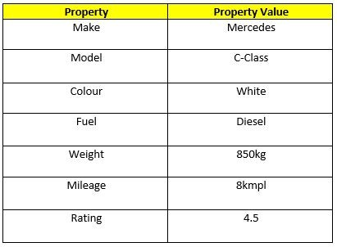

No alt text provided for this image

The object properties can be different primitive values, other objects and functions.

Properties can usually be changed, added, and deleted, but some are read only.

The syntax for adding a property to an object is:

ObjectName.ObjectProperty = propertyValue;

The syntax for deleting a property from an object is:

delete ObjectName.ObjectProperty;

The syntax to access a property from an object is:

objectName.property // Car.Make

//or

objectName["property”] // Car["Make"]

//or

objectName[expression] // x = "Make"; Car[x]

So, Conclusion and simple definition for Java Script properties is “Properties are the values associated with a JavaScript object”.

3)Object Methods

An object method is an object property containing a function definition.

i.e.,

Let’s assume to start the car there will be a mechanical functionality.

function () {return ignition. On}

and so similar is to stop/brake/headlights on & off, etc.

(I’m just trying to roll a picture in your mind. The car will not start / stop by means of code. I assume you’d get it).

Conclusion

So, Conclusion and simple definition for Java Script Object methods is “Methods are actions that can be performed on objects.”.

REF: <https://www.linkedin.com/pulse/objects-its-internal-representation-javascript-satya-prasad-behara/>

NOTE:

MAKING THIS BLOG DOCUMENT I HAVE GOT AN IDEOLOGY OF OBJECT OPERATIONS IN A JAVASCRIPT ITS MAKES ME TO LERAN MORE ABOUT IT.